Table of Contents
Installing Atom 1

Installing Atom
In order to install atom you want to go to: https://atom.io/ and install using the windows installer.
The window installer will install the atom and it will also add atom and apm commands to your PATH, create a shortcut on the desktop and in the start menu.

Atom basics
Clicking ctrl+shift+p will pop up the command palette below:
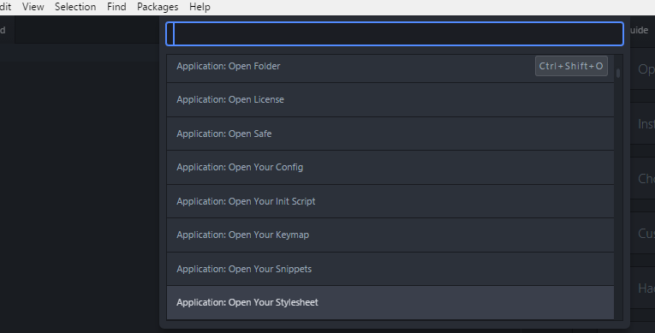

The command palette will let you see thousands of commands and also display the keybindings associated to that command.

Angular JS Jargen
Single Page Applications, templating, MVC
The idea is that you load a single application and load different pieces of the page with partials.
Templates are the way the design will look.
MVC is the design-pattern enforce by the framework

Core features
- Directives
- Data binding
- Filters
- Modules – broken up by functionality
- Routes
- Controllers

Installing Angular
Visit angularjs.org and click install.
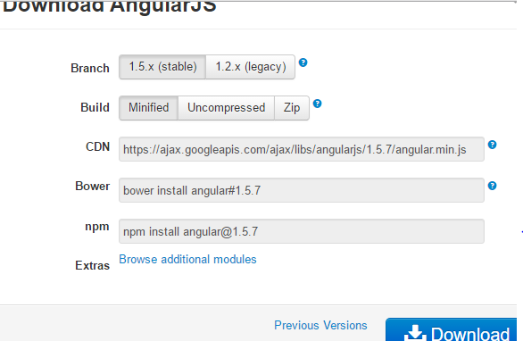

Chose your favorite version

Building a basic angular applicaiton
Create a index.html and add the code below to test that angular has been installed.
ng-app and ng-model are the first directive we will use
